# **4. INTRO TO THE CLI**

### **What is a CLI?**

* A "Command-line Interface"
* The interface you use to configure Cisco devices

A GUI is a "Graphical User Interface."

### **How do you connect to a Cisco Device?**

* **Console Port:** When you first configure a device, you have to connect via the Console Port.

You can use a "Rollover cable":

* DB9 serial connector to RJ45
* OR a DB9 Serial to USB

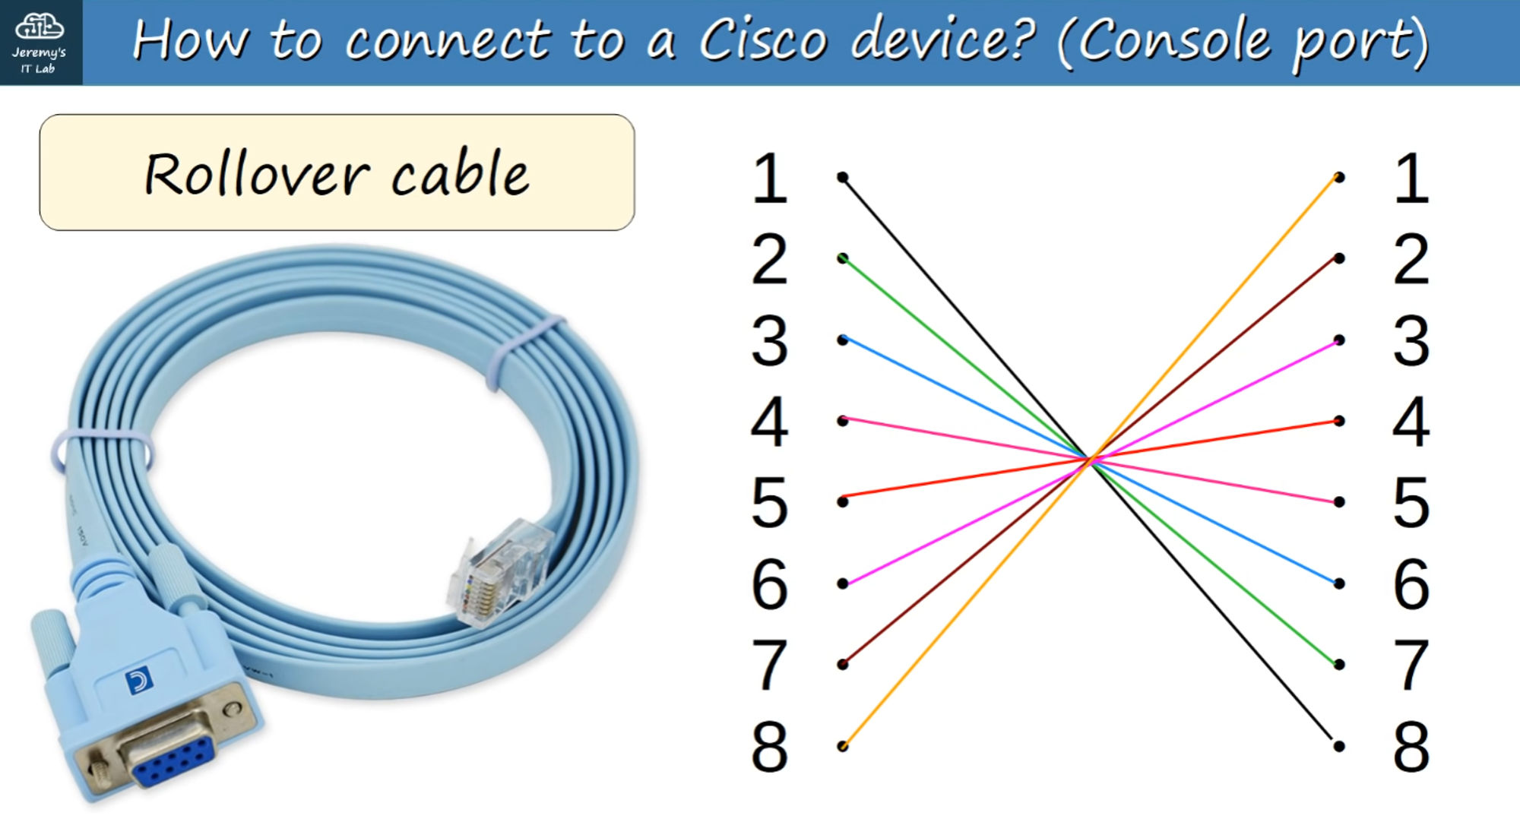

### **How do you actually access the CLI?**

* Use a **Terminal Emulator** (e.g., PuTTy is a popular choice) and connect via "Serial" (default settings).

### **Cisco Default Settings are:**

* **Speed (baud):** 9600 bits/second
* **Data bits:** 8 data bits
* **Stop bits:** 1 stop bit (sent after 8 data bits are sent)
* **Parity:** None
* **Flow Control:** None

### **User EXEC Mode**

When you first enter the CLI, you will DEFAULT to 'User EXEC' mode.

**USER EXEC MODE:**

(Hostname)> // Prompt looks like THIS //

* User EXEC mode is very limited.
* Users can view some information but cannot make ANY changes to the configuration.
* Also known as 'User Mode.'

Using the enable command in User EXEC mode switches you to 'Privileged EXEC' mode.

### **Privileged EXEC Mode**

* Provides complete access to view the device's configuration, restart the device, etc.
* Cannot change the configuration but can modify the time, save the configuration file, etc.

**PRIVILEGED EXEC MODE:**

(Hostname)# // Prompt looks like THIS //

### **Using Commands in the CLI**

* **Question Mark (?):** Use ? to view available commands in ANY mode.
  + Combining ? with a letter or partial command will list all commands starting with those letters.

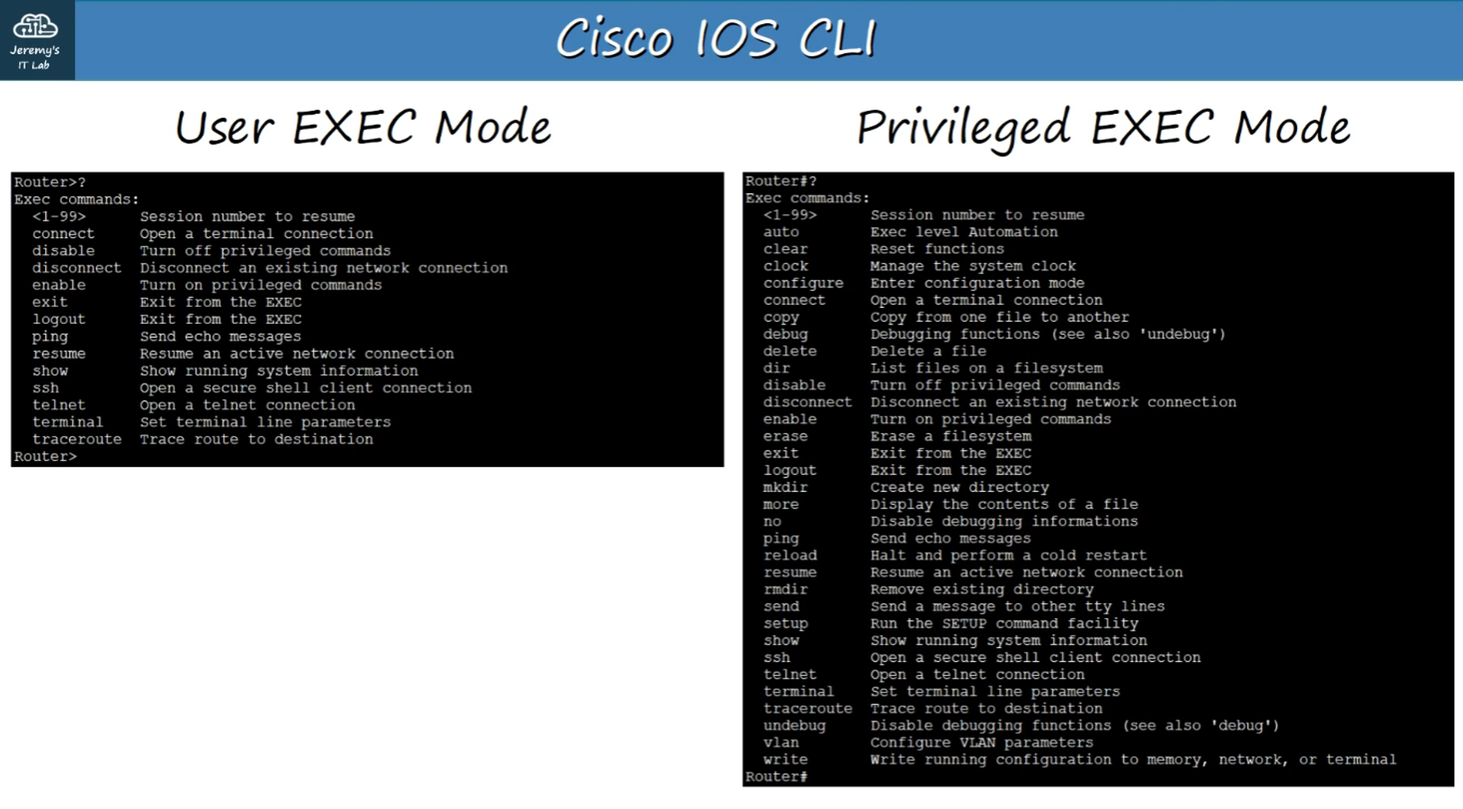

* **Tab Key:** Use the TAB key to auto-complete partially entered commands IF the command exists.

### **Global Configuration Mode**

To enter Global Configuration Mode from Privileged EXEC mode, use:

Router# configure terminal

OR

Router# conf t

**Prompt in Global Config Mode:**

Router(config)# // Prompt looks like THIS //

* Use exit to return to Privileged EXEC mode.

### **Setting Passwords**

To enable a password for User EXEC mode:

Router(config)# enable password <password>

* Passwords ARE case-sensitive.

To encrypt plain-text passwords visible in the configuration files, use:

Router(config)# service password-encryption

**Effects of Enabling 'service password-encryption':**

* Current passwords will be encrypted.
* Future passwords will be encrypted.
* The enable secret command is NOT affected.

**Effects of Disabling 'service password-encryption':**

* Current passwords will NOT be decrypted.
* Future passwords will NOT be encrypted.
* The enable secret command is NOT affected.

To enable passwords for Privileged EXEC mode:

Router(config)# enable secret <password>

* The enable secret password will ALWAYS be encrypted (using MD5, level 5 encryption).
* The enable secret command overrides enable password if both are set.

### **Configuration Files**

There are TWO separate configuration files stored on the device:

1. **Running-config:**
   * The current, ACTIVE configuration file on the device.
   * As you enter commands in the CLI, you edit this active configuration.
2. **Startup-config:**
   * The configuration file that will be loaded upon RESTART of the device.

**To view the configuration files in Privileged EXEC mode:**

Router# show running-config // for running config

OR

Router# show startup-config // for startup config

**To save the Running-config file to Startup-config:**

Router# write

Building configuration...

[OK]

OR

Router# write memory

Building configuration...

[OK]

OR

Router# copy running-config startup-config

Destination filename [startup-config]?

Building configuration...

[OK]

### **Encrypting Passwords**

**Steps to Encrypt Passwords:**

1. Enter Global Config Mode:

Router# conf t

1. Enable password encryption:

Router(config)# service password-encryption

This ensures:

* Current passwords are encrypted.
* Future passwords are encrypted.

**Note:** The enable secret password is always encrypted and is not affected by this command.

### **Encryption Types**

* **Type 7:**
  + Refers to Cisco’s proprietary encryption.
  + Weak encryption and easy to crack.

E.g. enable password 7 08026F6028

* **Type 5:**
  + Refers to MD5 encryption.
  + Stronger encryption but still crackable with effort.

**For stronger encryption, use the enable secret command.**

### **Canceling or Deleting Commands**

To cancel or delete a command you previously entered, use the no keyword.

**Example:**

Router(config)# no service password-encryption

* Current passwords will NOT be decrypted (unchanged).
* Future passwords will NOT be encrypted.
* The enable secret password remains unaffected.

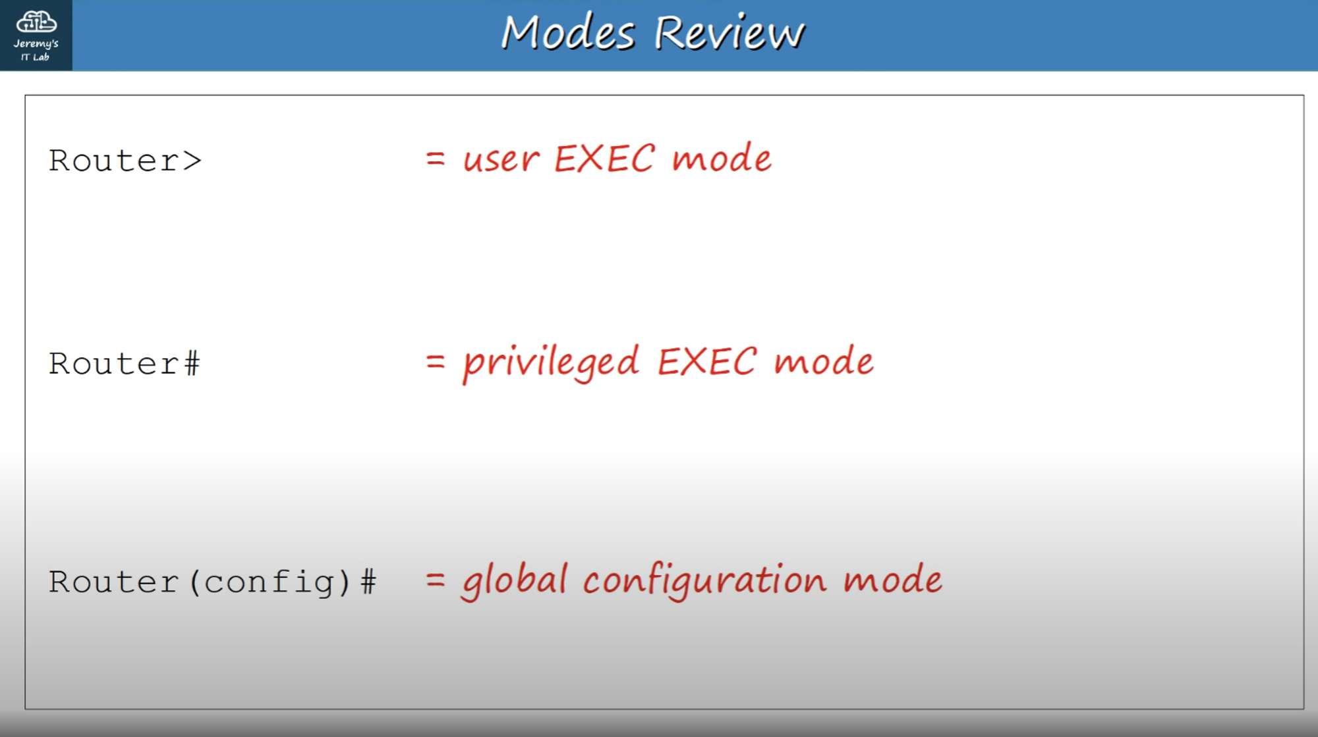

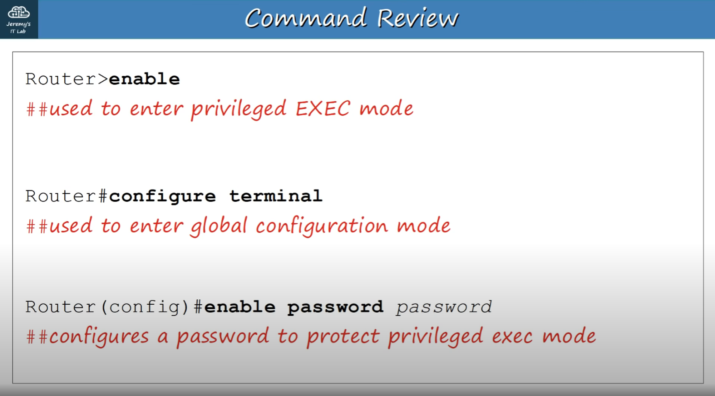

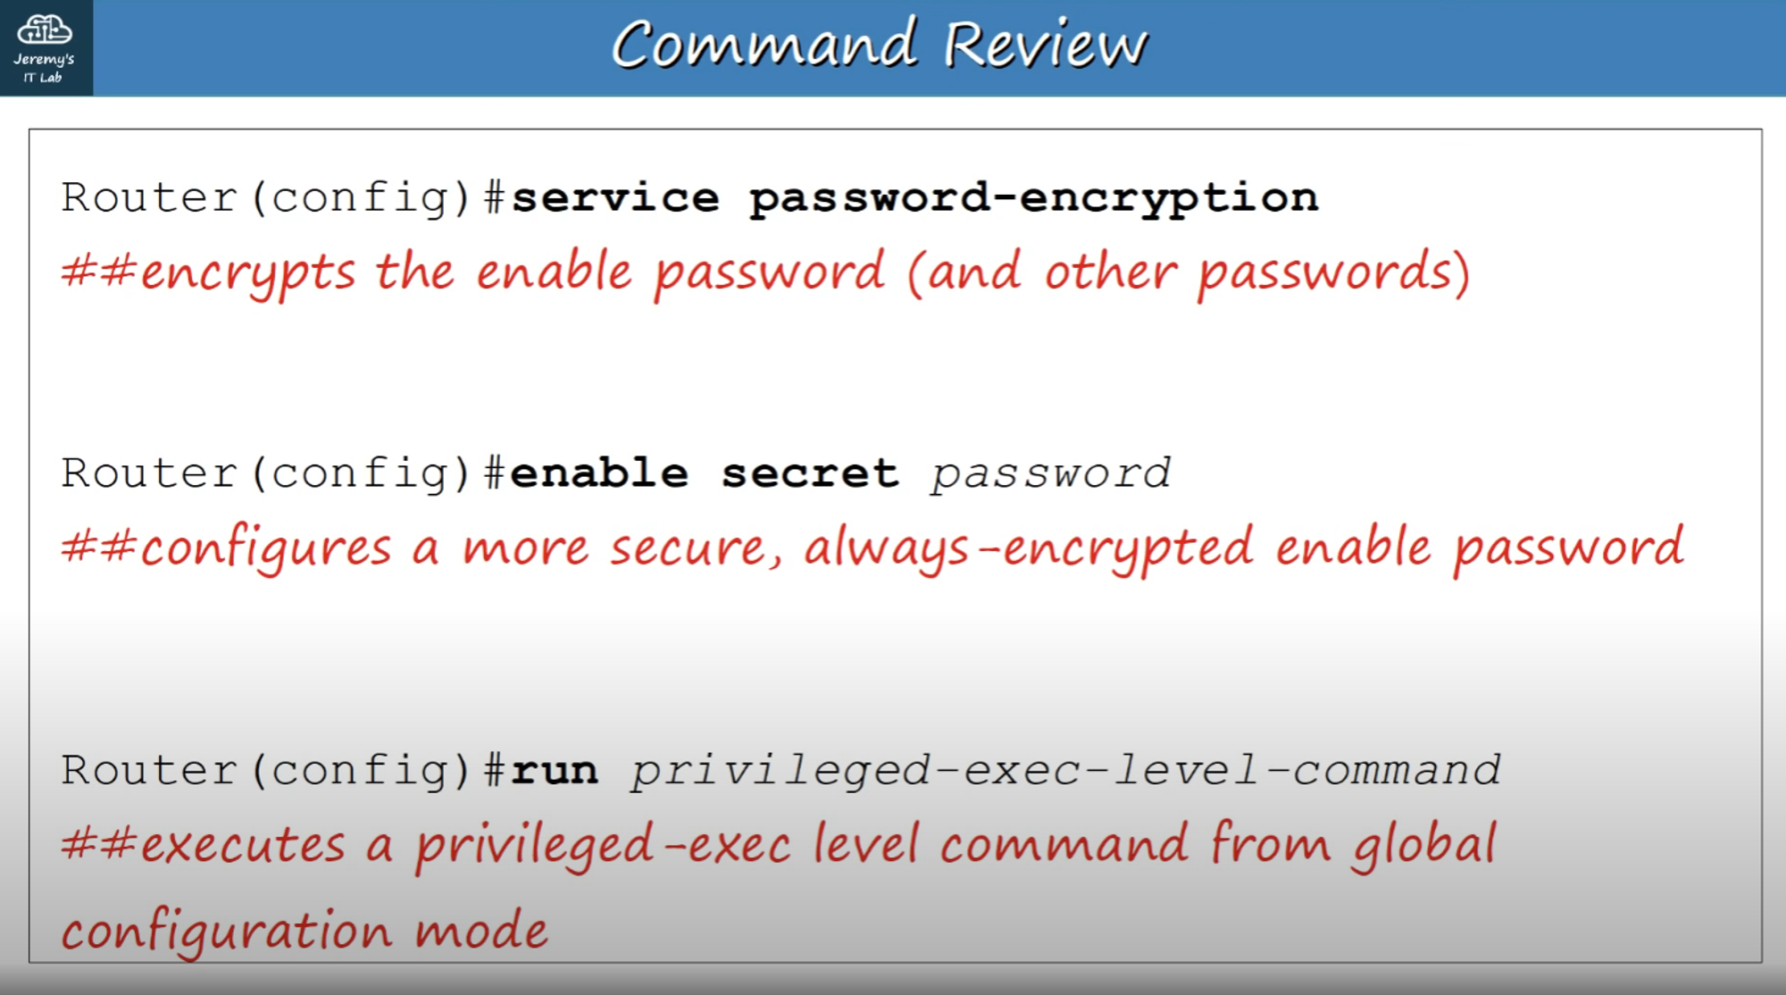

*It should be "Router(config)# do", NOT "Router(config)# run". "run" is the Juniper version, "do" is used on Cisco devices to let you execute privileged-exec level commands from global-config mode.*

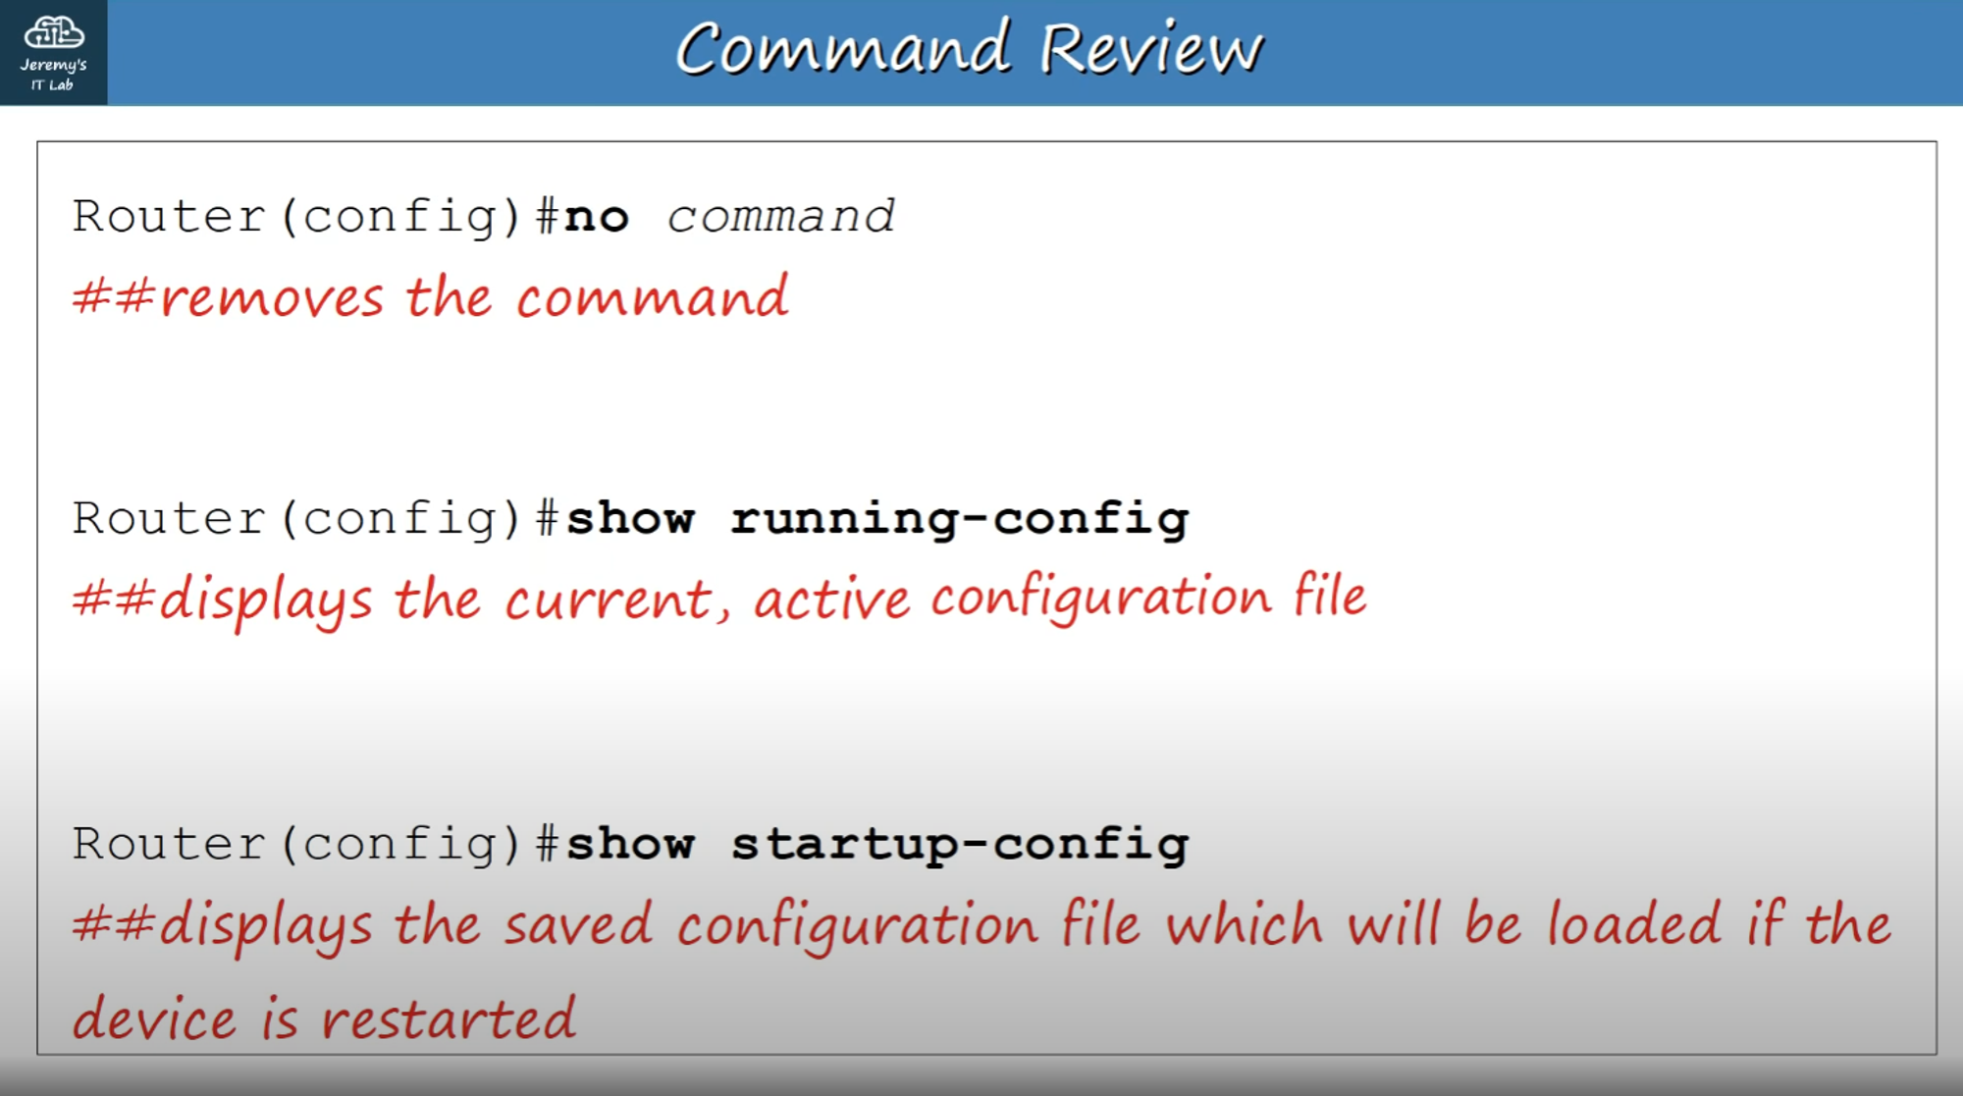*It should be 'Router# show running-config' and 'Router# show startup-config', etc. They should be entered in privileged exec mode, NOT global config mode.*

